**//MUHAMMAD BIN AKHTAR**

**//467463**

**//ME - 15 SEC-B**

**//LAB MANUALS-6**

**//TASK 01**

#include <iostream>

using namespace std;

int main ()

{

int terms, first=0, second=1,next;

cout<<"Enter the number of terms you want in the sequence: ";

cin>>terms;

cout<<"The sequence is: "<<endl;

for (int i=1; i<terms; i++)

{

for (int j=1; j<=i; j++)

{

cout<<first<<endl;

next=first+second;

first=second;

second=next;

}

}

return 0;

}

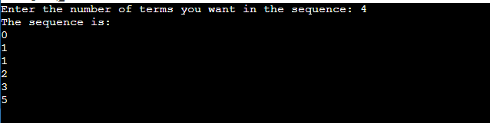

**//TASK 02**

#include <iostream>

using namespace std;

int main ()

{

int size, number=1;

cout<<"Enter the no. of rows for floyd's triangle :";

cin >> size;

for (int i = 0; i<=size; ++i){

for (int j=0; j<=i; ++j) {

cout << number << " ";

++number;

}

cout<<endl;

}

return 0;

}

